Education: Preventive Care Screening and Guidelines

- Cervical Cancer Screening: ________________________________________________________________________________________________________________________________________________________________________________________________________________________

- Chlamydia/Gonorrhea: ________________________________________________________________________________________________________________________________________________________________________________________________________________________

- Breast Cancer Screening and Gail score: ________________________________________________________________________________________________________________________________________________________________________________________________________________________

- DEXA (Osteoporosis) Screening: __________________________________________________________________________________________________________________________________________________________________________________________________________________________________________

- Colonoscopy Screening: ________________________________________________________________________________________________________________________________________________________________________________________________________________________

- Breast Cancer Screening/Gail score: mammography
  - Offered every 1-2 years starting at age 40.
  - Gail score is calculated at ages 35-65.
- Cervical Cancer Screening: pap smear
  - Every 3 years age 21-29.
  - Every 5 years with co-testing for HPV ages 30-65.
- Chlamydia/Gonorrhea: cervical/vaginal swab
  - 24 years and younger who are sexually active it is recommended yearly.
  - Recommended in older women who are at increased risk for infection.
- DEXA (Osteoporosis) Screening: measurement of bone density.
  - 65 years and over it is recommended every 5 years with normal results.
  - In younger women who's fracture risk is equal to or greater than that of a 65 y/o female with no additional risk factors.
- Colonoscopy Screening:
  - Recommended at 45 years and older every 10 years with normal results.

Education: Menopausal symptoms
Menopause is the end of a woman's menstrual cycle and fertility. It occurs when the ovaries no longer make estrogen and progesterone. These are the two hormones needed for a woman's fertility and periods. This most often occurs naturally with age; however, it can also happen as a result of:
- __________________________
- __________________________
- __________________________
Premenopausal:
- In this stage, menstrual cycles are irregular but have not stopped.

Menopause:
- This stage begins when a woman has had their final menstrual period. Women will not be able to pinpoint their final period until they've been completely free from periods for 1 year.

Postmenopausal:
- This stage happens after a woman has had no periods for at least 1 year.

Molly Menopause

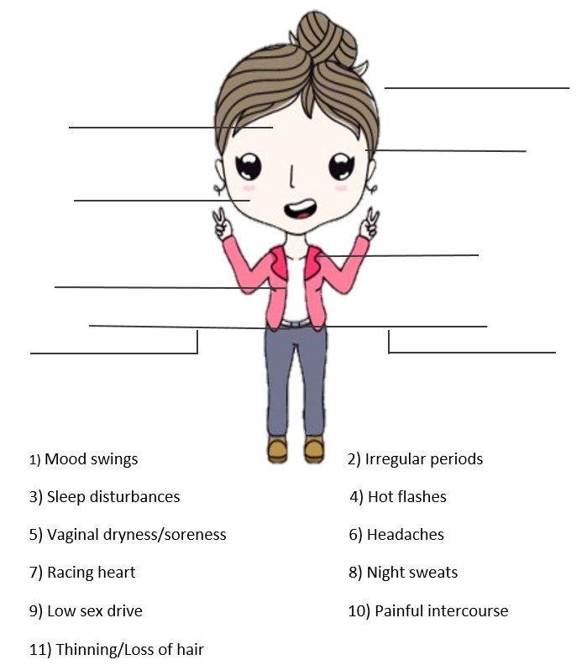

Education: Pap smear Results
Normal: means that no abnormal cells were detected in the sample taken from the cervix and it is unlikely that cervical cancer is present.
Inconclusive (also called ASC-US): ASC-US stands for atypical squamous cells of undetermined significance. This means that the cells do not look normal but they do not look abnormal either and therefore are referred to inconclusive.
- Negative for HPV: meaning no HPV has been found in the cervical cells.
- Positive for HPV: meaning that high-risk HPV, the type that can cause cancer, has been found in the cells. In particular HPV 16 or 18, which are responsible for 70% of all cervical cancers. Having HPV does not necessarily mean a patient has cervical cancer or will get cervical cancer.
Abnormal: this indicates that cell changes caused by HPV are present. These changes can be mild, moderate or severe. Most often these cells do not mean cancer, however more severe abnormal cells may progress to cancer over time. These abnormal results are often designated as Dysplasia, (SIL) squamous intraepithelial lesions, or (CIN) cervical intraepithelial neoplasia.
- Low-grade SIL (LGSIL) or CIN1
- High-grade SIL (HGSIL), CIN 2 or 3
- Atypical squamous cells, cannot exclude HSIL (ASC-H)
- Atypical glandular cells (AGC)
- Cancer

Low-grade SIL (LGSIL) or CIN1: mild abnormal cells that usually go away on their own.
High-grade SIL (HGSIL), CIN 2 or 3: moderate to severe abnormal cells, indicating more severe changes. CIN 3 may also be referred to as carcinoma in situ.
Atypical squamous cells, cannot exclude HSIL (ASC-H): Changes in the cervical cells have been found and are not clearly HSIL however could be. Further testing is needed.

Atypical glandular cells (AGC): seen changes in the cells that suggest precancer of the upper part of the cervix or uterus.

Cancer: Abnormal cells may have spread deeper into the cervix or to other tissue.

Pap smear Management/Treatment

Depending on the pap testing result, a clinician may recommend the following:

- Routine testing, according to guidelines. Depending on age and test received, this may be every 3 years and/or cotesting every 5.

- Follow-up testing: Pap and/or HPV testing in 1 year.

- Colposcopy: Procedure

Treatment of cervical changes are determined by many factors. CIN usually goes away on its own, therefore, in women 21-24 years it is monitored with repeat pap tests. Treatment is not needed unless there is an HSIL Pap result. Women that are 25 years and older, treatment is not needed unless CIN1 has been present for 2 years, the CIN1 becomes CIN2-CIN3, or there are other medical problems. Types of treatment are:

- Loop electrosurgical excision procedure (LEEP): A thin wire loop that carries electric current and is used to remove abnormal areas of the cervix that are then sent to lab for study. This is usually scheduled in office with a local anesthesia.

- Cone biopsy: A cone-shaped wedge of the cervix is removed for study. This can be done either (IOS) in office surgery with conscious sedation or in an operating room with general anesthesia.

- Freezing (Cryotherapy): This technique freezes abnormal tissue, which later sheds these abnormal tissue/cells.

- Laser treatment: this uses a beam of light that destroys abnormal tissue.

Safe Injection Practices
- Use aseptic technique to avoid contamination of sterile injection equipment
- Whenever possible, use single-dose vials for parenteral medications.
- Needles, cannulae, and syringes are sterile, single-use items. They must never be reused for another patient, nor to access a medication or solution that might be used for a subsequent patient
- Enter medication vials with a new, sterile needle
- Do not administer medications from a syringe to multiple patients, even if the needle or cannula on the syringe is changed
- Use fluid infusion and administration sets (i.e. intravenous bags, tubing and connectors) for one patient only and dispose appropriately after use. Once it has been used to enter or connect to a patient’s intravenous infusion bag or administration set, consider a syringe or needle/cannula contaminated.
- Medications that are pre-drawn are labeled with the time of draw, initials of the person drawing, medication name, strength, and expiration date or time. Pre-drawn medications expire at the end of the work day
- Each time the rubber septum on a multi-dose vial is accessed, it must be disinfected with alcohol and allowed to dry
- Multi-dose medications used for more than one patient are dated when they are first opened and are discarded within 28 days of opening or according to manufacturer’s recommendation, whichever comes first
- Draw up viscous (thick) medications with an 18 gauge needle and then administer with appropriate size needle.

Maximum medication volume to be administered per site
  - IM Ventrogluteal: 3 ml
  - IM Deltoid: 1 ml
  - SQ various sites: 1 ml (adult) 0.5 ml (infant/child)

8 rights of medication administration
All clinical employees have a responsibility for ensuring medications are administered correctly by following the 8 rights of medication administration:
- The right patient
Verify the patient is the correct patient, check their name and birthdate
- The right drug
Verify the drug, medication or vaccine has been ordered by the clinician, and verify this with the patient
- The right dose
Verify the dose with the medical record
- The right route
Verify route given (oral, intramuscular, subcutaneous, intradermal or IV)
- The right time
Verify the timing of the administration is correct
- The right to know information about the medication given
Patients need to be informed and educated about medications given in WHA. Explain the medication that you are going to give, take a few minutes to review the vaccine information statement, patient education materials, or consent forms that are provided to the patient. Give the patient an opportunity to ask questions, and consult with the clinician if needed
- The right to refuse the medication
If a patient decides to decline the medication, inform the clinician who ordered it and document
- The right documentation
Accurate, complete documentation in the correct patient electronic medical record. This documentation includes medication name, strength, dose, route, VIS date, consent forms, manufacturer, lot number, NDC and expiration date

Vaccines offered by WHA
All immunizations given by WHA are given IM in the deltoid muscle.
Quadrivalent Flu Vaccine (Fluzone) - Given yearly to protect against seasonal influenza. The seasonal flu vaccine protects against the influenza viruses that research indicates will be most common during the upcoming season. Our flu shots have no preservatives.
High Dose Flu Vaccine – Given to patients age 65 and older, it contains four times the standard dose of the regular flu shot.
Tdap – Vaccine that protects against three different bacteria: tetanus, diphtheria, and pertussis (whooping cough). Boosters are needed every ten years. Also given to women in the third trimester of every pregnancy, usually at 28 week visit. It helps protects infants from pertussis through passive immunity. Infants won’t get this vaccine until two months old.
Gardasil (HPV)- Gardasil is used to prevent genital warts, cancer of the cervix, anal cancer, and various cancers of the vulva or vagina. The administration of Gardasil has been associated with syncope (fainting), sometimes resulting in injury when falling. The syncope sometimes is associated with tonic-clonic movements and other seizure-like activity. Caution is recommended when administering the vaccine to individuals susceptible to syncope. Prior to vaccine administration, obtain a full set of vital signs (BP, P, T, Ht, Wt). Assess for history of prior syncopal episodes, if present, administer in a lying down position. Observe patient for 15 minutes for adverse vaccine reactions, ex: anaphylaxis, before discharging from clinic. Given in three separate doses. The second dose is given 2 months after the first dose. Third dose given 6 months after the first dose.

Commonly Administered Medications
Depo Provera (Medroxyprogesterone Acetate) – Depo-Provera is a form of progesterone, a female hormone that prevents ovulation (the release of an egg from an ovary). It also causes changes in your cervical mucus and uterine lining, making it harder for sperm to reach the uterus and harder for a fertilized egg to attach to the uterus. Do not administer if patient is pregnant. Prior to medication administration, obtain a full set of vital signs (BP, P, T, Ht, Wt). Observe patient for 15 minutes for adverse medication reactions, ex: anaphylaxis, before discharging from clinic. There is some flexibility with dosing. Can be given between weeks 11 – 15.
Rhogam - used to prevent Rh immunization, a condition in which an individual with Rh-negative blood develops antibodies after exposure to Rh-positive blood. Given to RH negative women given at 28 weeks gestation and when experiencing bleeding in pregnancy.
Methotrexate- A medicine given for ectopic pregnancy. The medicine stops the fetus from growing. The mother's body then usually absorbs the fetal tissue. Because this medication is a chemotherapy drug, whoever draws up and administers this medication must wear full PPE, including double gloves. When charting this medication, it requires a dual sign off.
Hydroxy-progesterone (Makena) - Makena is a progestin indicated to reduce the risk of preterm birth in women with a singleton pregnancy who have a history of singleton spontaneous preterm birth. This medication is given weekly from 16-36 weeks gestation. Prior to medication administration, obtain a full set of vital signs (BP, P, T, Ht, Wt).
Rocephin (Ceftriaxone) - Ceftriaxone injection is used to treat certain infections caused by bacteria such as gonorrhea or pelvic inflammatory disease. Rocephin has to be reconstituted. Follow the instructions on the label; It can be diluted with 1:1 sterile water, 0.9% Sodium Chloride or 1% lidocaine (without Epinephrine) for IM administration only. Do not administer if patient has allergies to Rocephin or cephalosporins. Prior to medication administration, obtain a full set of vital signs (BP, P, T, Ht, Wt). Observe patient for 15 minutes for adverse medication reactions, ex: anaphylaxis, before discharging from clinic.
Ketorlac (Toradol)- Toradol (ketorolac) is a nonsteroidal anti-inflammatory drug (NSAID). Ketorolac works by reducing hormones that cause inflammation and pain in the body
Estradiol Valerate (Delestrogen) is a form of estrogen used to treat symptoms of menopause such as hot flashes, vaginal dryness, burning and irritation. Very thick.
Testosterone cypionate (Depo-Testosterone) is a form of testosterone used for hormone replacement therapy. Very thick.
Depot Lupron - Lupron is a synthetic gonadotropin-releasing hormone used to treat symptoms of endometriosis and/or uterine fibroids. Do not administer if patient is pregnant or has allergies to leuprolide or similar medicines such as buserelin, goserelin, histrelin, or nafarelin. Prior to medication administration, obtain a full set of vital signs (BP, P, T, Ht, Wt). Observe patient for 15 minutes for adverse medication reactions, ex: anaphylaxis, before discharging from clinic

OB Education

Detailed Obstetric Notation

In an obstetrical history the gravida (G) and para (P) status of a woman is often written in abbreviated form.
Where:
(G)=Gravida: the number of pregnancies a woman has had. A multiple gestation counts as a single pregnancy.
(P)=Para: the number of completed pregnancies beyond 20 weeks gestation (whether viable or nonviable). A multiple gestation counts as a single birth.
Expanded obstetric notation gives more detail: G, T-P-A-L = Gravida (Total number of pregnancies), Term births -Preterm births - Abortions - Living children
Where:
Term births means delivery at 37 or greater weeks' gestation.
Preterm birth means delivery at 20 to 36 6/7 weeks' gestation
Abortion is delivery before 20 weeks' gestation.
Living children means children who are alive.

Pregnancy History:

History: | G | P
 | # of pregnancies | # of pregnancies  a woman has carried to viability
Examples:
G₁P₁: 1 pregnancy, 1 delivery
G₂P₁: 2 pregnancies, 1 delivery
- patient could be pregnant now
- patient could have had a pregnancy loss
(sp. Ab, el Ab, ectopic pregnancy, preterm delivery or infant death)
the above system is vague, so use this system:
G ___ P___ / ___/ ___ /___
G = gravidity (number of pregnancies)
P = parity P___ /___ /___ /___
T P A L
T = Term Deliveries
P = Preterm deliveries
A = Abortions (includes elective, spontaneous, ectopic, molar pregnancies – anything < than 20 weeks)
L = Living
Examples:
- G₁P₁₀₀₁
- G₂P₂₀₀₂
- G₂P₂₀₀₁
- G₂P₂₁₀₃

1st Trimester: (1 < 12 weeks)
  - 10 weeks 1 day: Earliest dating for NIPT
  - 12 weeks (or generally at the OB Workup appt.): OB panel which includes: blood type, Rh, anemia, rubella, Hepatitis B & C, RPR (syphilis), HIV, and a urine culture. Chlamydia/gonorrhea swab and potentially a pap. Dating and viability ultrasound may be offered.
2nd Trimester: (13 - 27 weeks)
  - 20 weeks: Anatomy Ultrasound
3rd Trimester: (= >28 weeks)
  - 28 – 29 weeks: 1 Hour GTT, ABC, RPR, Antibody Screening (if indicated meaning patient is documented as RH negative)
    - Tdap
    - Rhogam if indicated
      - Can be given same day as Antibody Screening (ABS)
      - ABS should not be drawn more than 24 hours after Rhogam has been administered
  - 36 week: collection of (GBS) Group B culture

6-28wk seen every 4 wks. - 28-36wks seen every 2 wks. - 36-delivery seen weekly

Gestational Diabetes
Diabetes in Pregnancy

Pre Gestational Diabetes Gestational Diabetes
(before pregnancy) 10% (develops during pregnancy) 90%

Hormones released during pregnancy:
  - hPL (human placental lactogen)
  - Cortisol (bodies main stress hormone)
  - Growth hormone
  - Progesterone
Poorly controlled at conception or within the 1st 8weeks-organogenisis
Have lots of important roles.
- One role is it increases moms production of glucose to make sure the fetus has enough glucose (primary fuel source)
When fetal organs formed

Diabetes complications:
- Preterm labor
- Problems with growth of fetus
- Stillbirth
- Fetal Macrosomia

Increases moms glucose
- These hormones make mom resistant to insulin.
- Cells don’t respond to insulin. Therefore not taking up as much glucose.
- Reduce mom’s utilization so baby has more.
Glucose in mom

Baby’s glucose

Baby’s insulin
Crossing the placenta to the baby

Drives insulin release, allowing glucose to be taken up

Macrosomia
“Large body”
Binds to receptors of heart and liver
Stimulates fat storage
Organ growth

Gestational Hypertension
Chronic/pre-existing HTN
20 wks.
Gestational HTN
Eclampsia - Seizures
Pre-eclampsia- (general)*140/90 (HTN)
Proteinuria
Edema (swelling)

Symptoms/Systemic findings:
Headaches
Visual changes
Sudden weight gain
Right upper quadrant pain (liver)
Decreased Fetal growth restrictions

End-organ damage:

Increased liver enzymes (LFT’s 2x normal)
- Suggests liver dysfunction
Increase Creatinine (= or>1.1)
- Eludes to kidney damage
Decrease Platelets (less than 100 K)
- Hints a clot formation

Antenatal testing:
  - Non stress test
  - Ultrasound
Additional office visits

Non-stress test (NST)

What is a non-stress test?
A simple non-invasive test performed during pregnancies over 24 weeks gestation (in the 3^{rd.} trimester) to evaluate a babies condition. It measures the fetal heart rate, fetal movement and uterine activity to ensure there’s no fetal distress.

Results of a non-stress test are considered:
- Reactive: Results are considered normal (reactive) if a baby’s heartbeat accelerates to a certain level above the baseline two or more times for at least 10 seconds each in a 10 - 20 min period before 32 weeks gestation. For 32 weeks gestation or later accelerations must occur for at least 15 seconds each in a 10 - 20 min period.
- Nonreactive: If the baby’s heartbeat doesn’t meet the above criteria described, the results are considered nonreactive. This result might take place if the baby is inactive or asleep during the test.

If the test is extended to 30-40 min with the baby results remaining nonreactive and the patient is not full term (39wks.) the clinician will likely do another prenatal test to further check the baby’s health. For example:
- Biophysical profile (BPP): this profile combines a non-stress test with a fetal ultrasound that evaluates the baby’s breathing, body movement, muscle tone and
Amniotic fluid level (AFI).

Interpretation of a tracing include:
  - Uterine activity (contractions)
  - Baseline fetal heart rate (FHR)
  - Baseline FHR variability
  - Presences of accelerations and/or decelerations
  - Changes or trends of FHR patterns over time.
Uterine activity: several factors are used in assessing this such as frequency, duration and interval of contractions.
Baseline fetal heart rate: is determined by approximating the mean FHR rounded to increments of 5 beats per minute (bpm) during a 10 minute window and must be at least 2 minutes of identifiable baseline segments in any 10 minute window but not necessarily connecting.

Baseline FHR variability: is defined as fluctuations in the baseline FHR that are irregular in magnitude and frequency, determined in a 10 minute window and does not include accelerations or decelerations.
  - Absent: undetectable
  - Minimal: greater than undetectable, but less than or equal to 5 bpm
  - Moderate: 6-25 bpm
  - Marked: greater than 25 bpm
Accelerations: is a visually apparent abrupt increase in FHR. The peak must be greater than or equal to 15 bpm and last greater than or equal to 15 sec from the onset to return to baseline in order to be called an acceleration.
  - Note: a prolonged acceleration is greater than or equal to 2 min but less than 10 min in duration.
Periodic or episodic decelerations: periodic refers to decelerations that are associated with a contraction and episodic refers to decelerations not associated with contractions.
  - Early Decelerations: Usually symmetrical, gradual decrease and return to FHR associated with a contraction. This occurs at the same time as the peak of the contraction
  - Late Decelerations: Usually symmetrical, gradual decrease and return to FHR associated with a contraction. This is delayed in timing, occurring after the peak of the contraction.
  - Variable Decelerations: Abrupt decrease in FHR is greater than or equal to 15 bpm, lasting greater than or equal to 15 sec and less than 2 min in duration. When variable decels are associated with uterine contractions, their onset, depth, and duration commonly vary with following contractions.
  - Prolonged Decelerations: Decrease in FHR from baseline greater than or equal to 15 bpm, lasting greater than or equal to 2 min, but less than 10 min.

Indications and Contraindications

Pregnant women at risk for intrauterine compromise may be considered a candidate for non-stress testing such as:

- Gestational hypertension, chronic hypertension
- Post dates
- Gestational Diabetes Mellitus (GDM), Diabetes Mellitus
- History of pervious stillbirth
- Suspected intrauterine growth restrictions (IUGR)
- Absence or decreased fetal movement
- RH sensitization

Appendix

Phone Results Scripting
Phone Scripting for Results
Use the following scripting as a guideline for delivering results to patients via phone. You do not have to read the scripting word-for-word. It is intended to help you become familiar with the key points to hit when delivering results, and to have answers to some basic questions.
If a patient doesn’t answer and we do not have a Release of Information on file to leave detailed voicemails…
“Hello, this is [insert your name here] calling from your doctor’s office. Please give me a call back at [insert clinic phone number here].”
Elevated 1 Hour GTT, Needs 3 Hour GTT:
Suggested scripting:
“Hello, this is *** calling from Women’s Healthcare Associates. Is this [insert patient name here]? I’m calling because we’ve received the results of your 1 hour glucose tolerance test, or GTT. It did come back elevated and your provider would like you to have some additional screening. It’s called a 3 hour glucose tolerance test.
You will need to be fasting for this test, so nothing to eat or drink besides water for at least 8 hours, but no more than 24 hours, before the test. Required medications may be taken during this fasting time, but if you’re taking a medication that affects your metabolism of glucose you’ll want to speak with your provider about it before you take this test.
This test consists of four blood draws. One will occur prior to drinking the glucose drink, and then three additional blood draws will occur at 1 hour intervals after drinking the glucose drink. This test takes around 4.5 hours to complete and you’ll be required to stay in the office for the entire time of the test, so bring some sort of quiet entertainment for yourself like a book or tablet. It is also a good idea to bring a protein based snack for when you’ve fully completed the test to avoid symptoms of hypoglycemia, or low blood sugar. Do you have any questions?”
Frequently Asked Questions:
- Can I have black coffee or Tea? No, you may sip one 8oz glass of water per hour during the fasting &/or testing period.
- Can I leave the waiting area during the testing period? No, plan on being in the waiting area during the testing period except for bathroom breaks. This is for your own safety. In addition, walking or exercise can affect the test results. It is also important for you to have your blood drawn within the scheduled times. The phlebotomist will inform you when each of your blood draws are due.
- What happens if my blood is not drawn during the appropriate time window? If blood is drawn outside the acceptable window, then the test will have to be cancelled and rescheduled. Changes to the time of draw make interpreting the test difficult.
- May I smoke during the testing period? No, smoking is not permitted during the testing period as it can alter results.
- What happens if I get sick or vomit during the test? Please let the staff know right away if you are starting to feel ill. Staff will discuss a plan with your provider.

Anemia:
Suggested scripting:
“Hello, this is *** calling from Women’s Healthcare Associates. Is this [insert patient name here]? I’m calling because your recent bloodwork has shown that you are anemic, this means your blood has a low blood cell count, which can cause you to feel tired and weak as you have fewer blood cells. The most common cause of anemia is not having enough iron. Your body needs iron to make hemoglobin. Hemoglobin is an iron-rich protein that gives the red color to blood. It carries oxygen from the lungs to the rest of the body.
Your provider recommends (relay provider’s plan, this may often include taking a daily iron supplement and repeat labs. If this is the case, carefully explain to the patient when and how to take the iron supplement and when they need to be back in the clinic for repeat labs). Do you have any questions?”
GBS Positive:
Suggested scripting:
“Hello, this is *** calling from Women’s Healthcare Associates. Is this [insert patient name here]? I’m calling because we got your GBS result back. It was positive.
This means that you are a carrier for the group B streptococcus bacteria, which is a normal bacteria found in the vagina and rectum. It usually doesn’t cause any symptoms to women, but can be harmful to babies during labor. So, your provider will treat you with antibiotics while you’re in labor to prevent transmission to the baby.
That being said, if your water breaks at home, please call us as soon as possible, because once that protective barrier of the amniotic sac opens, it’s more likely for the baby to get exposed to the bacteria. Do you have any questions?”

Rh Negative:
Suggested scripting:
“Hello, this is *** calling from Women’s Healthcare Associates. Is this [insert patient name here]? I’m calling because we’ve received your recent lab results and they show that you are Rh Negative.
This means that if there’s a possibility that your baby could have a positive blood type like AB Positive. If this happens, your body may create antibodies to fight off that positive blood type which can lead to serious health problems for your baby, or in future pregnancies. So, if you begin to have any vaginal bleeding, please call us as soon as possible.
Also, at 28 weeks you’ll be given an injection called Rh Immunoglobulin or Rhogam. This will prevent your body from creating antibodies toward your baby’s blood type. You’ll also receive this injection within 72 hours after you’ve given birth as well. Do you have any questions?”
Yeast Infection:
Suggested scripting:
“Hello, this is *** calling from Women’s Healthcare Associates. Is this [insert patient name here]? I’m calling to discuss your recent test result with you. Your test came back positive for yeast. It’s normal to have a small amount of yeast in the vagina, but when that balance between yeast and bacteria is shifted, either one can overgrow. In your case it happened to be the yeast (relay provider’s plan regarding medication prescribed, either pill or vaginal gel, and answer any questions they have).”

Bacterial Vaginosis:
Suggested scripting:
“Hello, this is *** calling from Women’s Healthcare Associates. Is this [insert patient name here]? I’m calling to talk to you about your recent test results. Your test showed an overgrowth of your normal vaginal bacteria, this is called Bacterial Vaginosis. Your provider has prescribed ***. (If provider is prescribing pill ensure patient knows not to drink alcohol with the medication because they will get sick or get a live vaccine as it can make it less effective. If they prescribe the gel remind the patient that it is a vaginal medication and can be messy.)”
Pap Smears:
Suggested scripting (general):
“Hello, this is *** calling from Women’s Healthcare Associates. Is this [insert patient name here]? I’m calling to talk to you about your recent pap smear.”
Normal results:
“Your pap smear was normal. That means that no abnormal cells were detected in the sample taken from the cervix and it is unlikely that cervical cancer is present. Do you have any questions?”
Inconclusive/ASC-US:
“Your pap smear had an inconclusive result, and your cells were ASC-US. ASC-US stand for atypical squamous cells of undetermined significance. This means that the cells do not look normal but the do not look abnormal either, and therefore the test is inconclusive.”
Negative for HPV: “No HPV has been found in the cervical cells.”
Positive for HPV: “HPV-16 and HPV-18 are two types of HPV that are responsible for 70% of all cervical cancers. High-risk HPV, the kind that can cause cancer, has been found in your cervical cells. However, having HPV does not necessarily mean that someone has cervical cancer or will get cervical cancer.”
Continue to the next page for more abnormal pap smear results scripting…
Abnormal:
“Your pap smear showed abnormal cells. This indicates that changes caused by HPV are present. These changes can be mild, moderate or severe. Most often, these cells do not mean cancer is present. However, more severely abnormal cells may progress to cancer over time. These abnormal results are often designated as Dysplasia a more general term, or squamous intraepithelial lesions (referred to as SIL), or cervical intraepithelial neoplasia (referred to as CIN) depending on where the cell changes are.”
Low-grade SIL (LGSIL) or CIN1: “Your cells show low-grade SIL or CIN1. This means cells are mildly abnormal, and usually go away on their own.
High-grade SIL (HGSIL), CIN2 or CIN3: “Your cells showed moderate to severe changes.” (CIN3 can also be called carcinoma in situ)
Atypical squamous cells, cannot exclude HSIL (ASC-H): “Changes in your cervical cells have been found that are not clearly HSIL, but could be. Further testing is needed.”
Atypical glandular cells (AGC/AGUS): “There are changes in the cells that suggest pre-cancer of the upper part of the cervix or uterus.” In general, providers and RNs will give this result.
Cancer: “Abnormal cells may have spread deeper into the cervix or to other tissue.” In general, providers and RNs will give this result.

Screening Diagnosis Codes
Weeks (Z3A series) cannot be the primary diagnosis on any order/study/visit.

It is best practice to use the WHA OB Return Visit when placing lab and imaging orders for pregnant patients. Using this tool will connect the appropriate diagnosis codes when the order is selected.
Pertinent questions:
Is desired study for screening or for diagnosis?
Screening = Testing for condition in well individuals
Diagnosis = Testing to rule out or confirm a suspected diagnosis because the individual has a sign or symptom

Is there another diagnosis associated with CPT?
If there is a diagnosis code, do not add a screening code
Example: Ultrasound for 36-yo G1; use ICD10 O09.512 (AMA), not Z36.3 (routine screening)

VISIT | STUDIES | ICD-10
New OB Workup | OB panel, Urine culture, GC/CT  Pap  HPV | Z36.89 Encounter for other specified antenatal screening  Z12.4 - Cervical Cancer Screening  Z11.51 - Encounter for screening for human papillomavirus (HPV)
Genetics | NT ultrasound ……  NIPT - Low Risk  NIPT – AMA Primigravida  NIPT – AMA Multigravida  Seq 1 labs ………………….  Screen CF/SMA | Z36.82 - Encounter for nuchal translucency testing  Z36.0 – Encounter for antenatal screening for chromosomal anomalies  O09.511 – AMA (advanced maternal age) primigravida 35+, first trimester  O09.511 – AMA (advanced maternal age) multigravida 35+, first trimester  Z36.89 - Screening for pregnancy-associated plasma protein A  Z31.430 - Encounter of female for testing for genetic disease carrier status for procreative management
Anatomy Ultrasound | Routine anatomy………  Follow-up suboptimal images | Z36.3 Screening, antenatal, for malformation by ultrasound  Z36.2 - Encounter for follow-up ultrasound of fetal anatomy
28 weeks | 1 hour GTT, RPR, ABC  Antibody Screening (RH Negative status only) | Z36.89 - Encounter for other specified antenatal screening  Z67.91 - Rh negative status during pregnancy in third trimester
36 weeks | GBS culture | Z36.85 - Encounter for antenatal screening for streptococcus B
Other | Influenza vaccine  Tdap vaccine | Z23 - Need for vaccination  Z23 - Need for vaccination

COVID-19 Throat swab collection
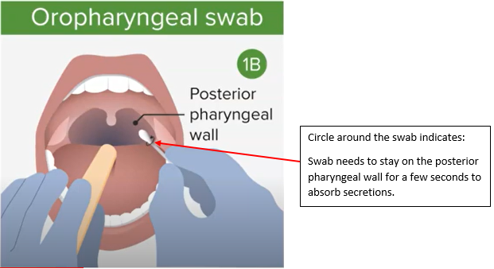

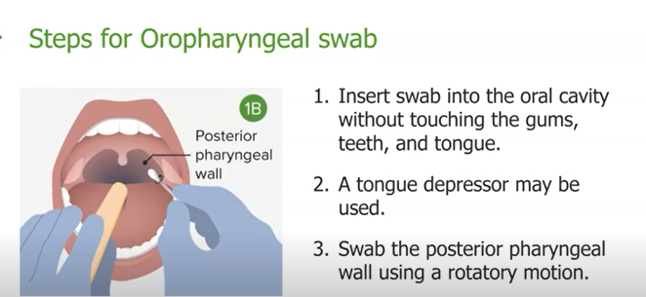
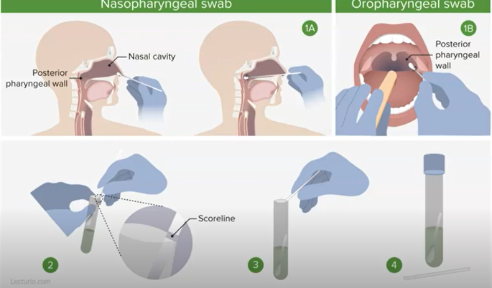

Refrigerate swab after collection if not taking directly to the lab.

Instrument Sterilization
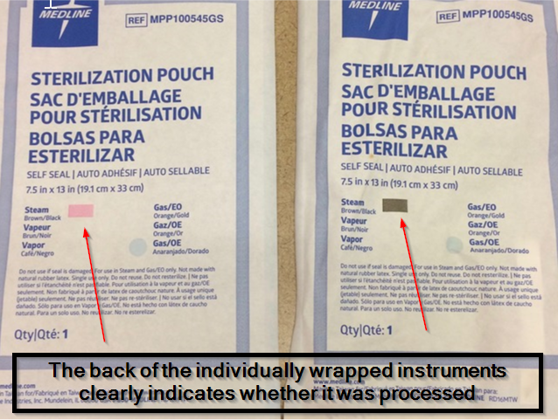
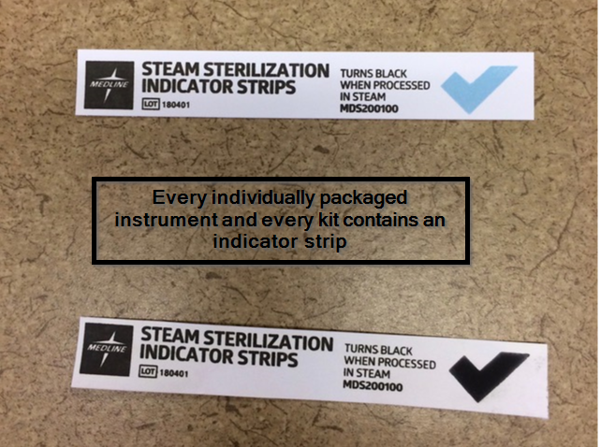
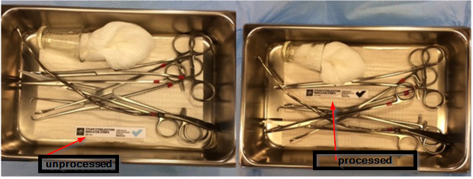
These indicator strips are also present in every instrument tray. Here is an IUD insertion pack.

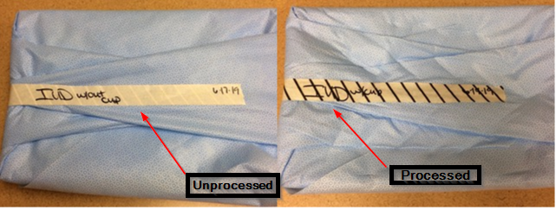
The tape on the outside of the sterile instrument packs have tape that changes once processed (has stripes)

Roles
Clinical Services:
- MA – Medical Assistant: Back office support staff to clinicians
- LPN – Licensed Practical Nurse: Back office support staff to clinicians
- RN – Registered Nurse
  - Perinatal Nurse
  - Advice Nurse
- Triage LPN – Triage support for advice nurses
- MD – Medical Doctor: Clinician
- CNM – Certified Nurse Midwife: Clinician
- APC – Advanced Practice Clinician: Clinician
- MFM – Maternal Fetal Medicine Doctor: Clinician
- LA – Lab Assistant: Phlebotomist (Can also be certified as a Medical Assistant)
- PCS – Patient Care Supervisor: Clinical Staff Supervisor
- PS – Practice Supervisor: Clinical and Patient Services Combined Supervisor
- PM – Practice Manager: Manages PCS/PS/PSS
Patient Services:
- MR – Medical Receptionist: Front office staff
- PSR – Patient Services Representative: Advanced front office staff
- PSS – Patient Services Supervisor: Front office staff supervisor
- Scheduling Specialist: Northwest Perinatal Scheduler

Helpful Contacts
Name | Phone Number | Internal Extension
Ultrasound Navigator | 503-296-7416 | 7416
Surgery Scheduler Backline | 503-445-7940 | 7940
West Hub Advice RN Backline |  | 1888
East Hub Advice RN Backline |  | 1889
South Hub Advice RN Backline |  | 1210
Behavioral Health Backline | 503-734-1090 | 1090
Financial Coordinator Backline | 503-734-1871 | 1871

Clinic | Frontline Ext. | Backline Ext.
Bridgeview | N/A | 4802
Gateway | 3818 | 3810
Hillsboro | 3411 | 3410
Tabor | 7850 | 8434
Newberg | 8103 | 8145
Oregon City | 4387 | 4343
Peterkort | 3778 | 3777
Tualatin | 5603 | 3600
NWG-PK | 3555 | 3868
NWP-E | N/A | 1815
NWP-W | N/A | 7403

Interpreter Services
Linguava: 971-202-7091
Clinic | Customer Codes | Clinic Phone Numbers (for call backs and transfers)
Tabor | 9850 | 503-249-5454
Gateway | 9544 | 503-734-3800
NWP-E | 9677 | 503-482-1800
NWP-W | 2002 | 503-297-3660
Peterkort | 2006 | 503-734-3700
NWG-PK | 2005 | 503-734-3535
Bridgeview | 19471 | 503-247-4800
Hillsboro | 14616 | 503-840-3400
Tualatin | 2003 | 503-692-1242
NWG-TN | 2003 | 503-692-1212
Oregon City | 9227 | 503-657-1071
Newberg | 2004 | 503-538-2698

Annual Exams (Preventive Visits) and Problem Visits
What is a preventive visit?
A preventive visit is a routine visit where overall general health is discussed and annual, or other regularly timed testing, is completed. These visits are focused on screenings for health conditions.

Can a problem be included in a preventive visit?
Potentially, but this is up to the provider and patient to decide together what the best course of action is for the patient’s care. It is best practice to inform the patient that there is a possibility that they may have to choose either completing their annual or addressing the problem they’d like to discuss and rescheduling their annual for another time. This depends on the complexity of the problem they want to have addressed.

When should a preventive visit change to a problem visit?
When the problem is too complicated for a provider to discuss their regular health maintenance topics, complete screenings, and cover the problem in the time allotted for the visit.
When complicated problems are mentioned by patients as a topic they’re concerned about, you can ask if they would like to change their visit from a preventive visit to a problem visit instead, and reschedule their preventive visit. This gives patients the option to choose what they would rather address.
If you are unsure whether a problem can be addressed during the preventive visit, inform the patient that you are unsure but that it would be up to your provider’s discretion whether the visit is changed to a problem focused visit. Then, discuss with the provider you are working with on whether it can remain a preventive visit or if it should be changed to a problem visit.

Notes
________________________________________________________________________________________________________________________________________________________________________________________________________________________________________________________________________________________________________________________________________________________________________________________________________________________________________________________________________________________________________________________________________________________________________________________________________________________________________________________________________________________________________________________________________________________________________________________________________________________________________________________________________________________________________________________________________________________________________________________________________________________________________________________________________________________________________________________________________________________________________________________________________________________________________________________________________________________________________________________________________________________________________________________________________________________________________________
______________________________________________________________________________________________________________________________________________________________________________________________________________________________________________________________________________________________________________________________________________________________________________________________________________________________________________________________________________________________________________________________________________________________________________________________________________________________________________________________________________________________________________________________________________________________________________________________________________________________________________________________________________________________________________________________________________________________________________________________________________________________________________________________________________________________________________________________________________________________________________________________________________________________________________________________________________________________________________________________________________________________________________________________________________________________________________________________________________________________________________________________________________________________________________________________________________________________
__________________________________________________________________________________________________________________________________________________________________________________________________________________________________________________________________________________________________________________________________________________________________________________________________________________________________________________________________________________________________________________________________________________________________________________________________________________________________________________________________________________________________________________________________________________________________________________________________________________________________________________________________________________________________________________________________________________________________________________________________________________________________________________________________________________________________________________________________________________________________________________________________________________________________________________________________________________________________________________________________________________________________________________________________________________________________________________________________________________________________________
__________________________________________________________
__________________________________________________________________________________________________________________________________________________________________________________________________________________________________________________________________________________________________________________________________________________________________________________________________________________________________________________________________________________________________________________________________________________________________________________________________________________________________________________________________________________________________________________________________________________________________________________________________________________________________________________________________________________________________________________________________________________________________________________________________________________________________________________________________________________________________________________________________________________________________________________________________________________________________________________________________________________________________________________________________________________________________________________________________________________________________________________________________________________________________________
__________________________________________________________
__________________________________________________________________________________________________________________________________________________________________________________________________________________________________________________________________________________________________________________________________________________________________________________________________________________________________________________________________________________________________________________________________________________________________________________________________________________________________________________________________________________________________________________________________________________________________________________________________________________________________________________________________________________________________________________________________________________________________________________________________________________________________________________________________________________________________________________________________________________________________________________________________________________________________________________________________________________________________________________________________________________________________________________________________________________________________________________________________________________________________________
__________________________________________________________
__________________________________________________________________________________________________________________________________________________________________________________________________________________________________________________________________________________________________________________________________________________________________________________________________________________________________________________________________________________________________________________________________________________________________________________________________________________________________________________________________________________________________________________________________________________________________________________________________________________________________________________________________________________________________________________________________________________________________________________________________________________________________________________________________________________________________________________________________________________________________________________________________________________________________________________________________________________________________________________________________________________________________________________________________________________________________________________________________________________________________________
__________________________________________________________

